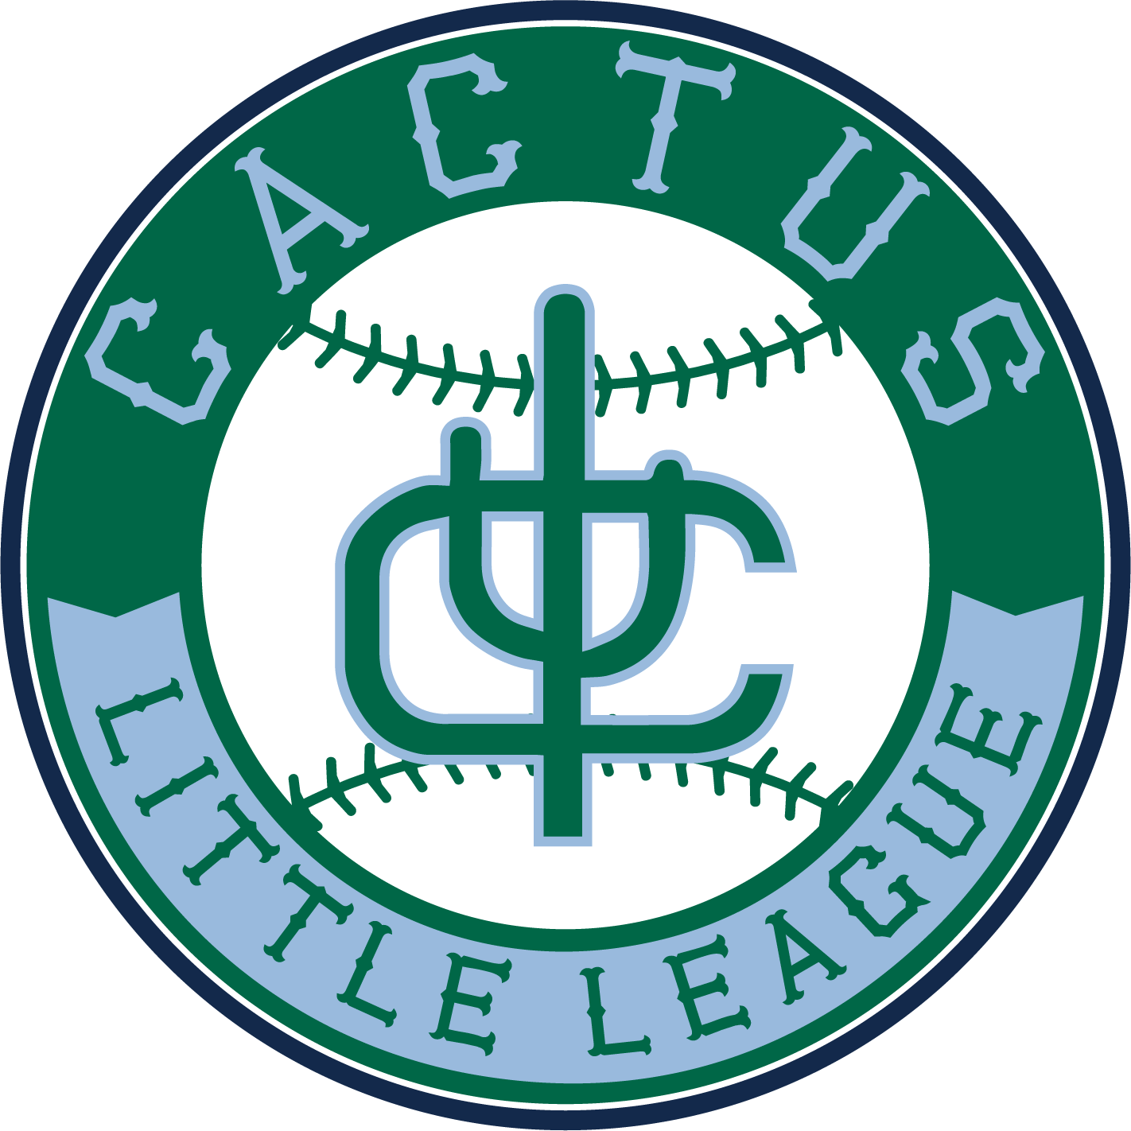
Dear Cactus Little League Community,

We are reaching out to ask that you consider becoming a sponsor of our program. Cactus Little League is a 501c3 non-profit youth program located in central Tucson and any donation to it is fully tax-deductible to the extent allowed by law, EIN 85-3707509. Our league is volunteer-run by a group of families who love baseball and softball and the opportunities it opens up to our young boys and girls. Our league fosters a love for baseball & softball and the opportunities it opens up for our children. Our players learn the importance of teamwork, setting goals, and communication skills. They learn to respect themselves, their volunteer coaches & umpires, and their teammates. They are also getting great exercise through a safe outdoor activity. Little League baseball & softball also sets a great foundation for participating members of our community into the future.

Your seasonal sponsorship enables us to keep our program running safely and efficiently for the children. Our goal this year is to raise $500.00 for each team; however, we offer a number of different sponsorship levels starting at $75.00. All sponsors will be recognized on our website as well as through communication distributed by Cactus Little League. Please reach out to me using the contact details below to arrange your sponsorship.

On behalf of the families and players of Cactus Little League, thank you very much for your consideration and support. We look forward to seeing you at our games this spring!

Sincerely,

Angela D’Acquisto
Cactus Little League Sponsorship & Fundraising Manager
ang_luciano@yahoo.com
925.262.7622

